Practice Short Answer Question – Period 1
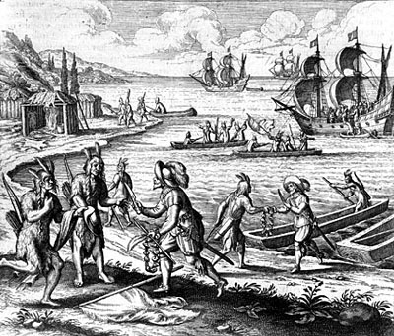

Use the image above and your knowledge of history to answer parts a, b and c. You must answer using complete sentences.
- Explain the point of view in the image regarding ONE of the following:
  - Commerce
  - American Indians
  - European exploration
- Explain how ONE element of the image expresses the point of view you identified in Part A.
- Explain how the point of view you identified in Part A helped to shape ONE significant historical event prior to 1754.

